|  |  |
| --- | --- |
| **Name:** | **Soham Ajit Dahanukar** |
| **Roll No:** | **13** |
| **Class/Sem:** | TE/V |
| **Experiment No.:** | 5 |
| **Title:** | Using open source tools Implement Association Mining Algorithms. |
| **Date of Performance:** |  |
| **Date of Submission:** |  |
| **Marks:** |  |
| **Sign of Faculty:** |  |

**Aim:** To implement Apriori Algorithm on large dataset using Open source tool WEKA.

**Objective:** To make students well versed with open source tool like WEKA to implement Apriori algorithm.

**Theory:**

* Association rule mining finds interesting associations and relationships among large sets of data items. This rule shows how frequently an itemset occurs in a transaction.
* A typical example is a Market Based Analysis. Market Based Analysis is one of the key techniques used by large relations to show associations between items.
* It allows retailers to identify relationships between the items that people buy together frequently.
* Given a set of transactions, we can find rules that will predict the occurrence of an item based on the occurrences of other items in the transaction.

| TID | Items |
| --- | --- |
| 1 | Bread, Milk |
| 2 | Bread, Diaper, Beer, Eggs |
| 3 | Milk, Diaper, Beer, Coke |
| 4 | Bread, Milk, Diaper, Beer |
| 5 | Bread, Milk, Diaper, Coke |

**Support Count ($σ$)** – Frequency of occurrence of a itemset.

Here $σ$ ({Milk, Bread, Diaper})= 2

**Frequent Itemset –** An itemset whose support is greater than or equal to minsup threshold.

**Association Rule –** An implication expression of the form X $→$ Y, where X and Y are any 2 itemsets.

Example: {Milk, Diaper} $→$ {Beer}

* WEKA contains an implementation of the Apriori algorithm. The algorithm works only with discrete data.
* It can identify statistical dependencies between groups of attributes.
* Apriori algorithm can compute all rules that have a given minimum support and exceed a given confidence.
* Clicking on the "Associate" tab will bring up the interface for the association rule algorithms.
* The Apriori algorithm which we will use is the default algorithm selected. However, in order to change the parameters for this run (e.g., support, confidence, etc.) we click on the text box immediately to the right of the "Choose" button. Note that this box, at any given time, shows the specific command line arguments that are to be used for the algorithm.
* WEKA allows the resulting rules to be sorted according to different metrics such as confidence, leverage, and lift. We can also change the default value of rules (10) to be 20; this indicates that the program will report no more than the top 20 rules. The upper bound for minimum support is set to 1.0 (100%) and the lower bound to 0.1 (10%).
* Apriori in WEKA starts with the upper bound support and incrementally decreases support (by delta increments which by default is set to 0.05 or 5%). The algorithm halts when either the specified number of rules are generated, or the lower bound for min. support is reached. Once the parameters have been set, the command line text box will show the new command line. We now click on start to run the program. This results in a set of rules. The panel on the left ("Result list") now shows an item indicating the algorithm that was run and the time of the run. You can perform multiple runs in the same session each time with different parameters. Each run will appear as an item in the Result list panel. Clicking on one of the results in this list will bring up the details of the run, including the discovered rules in the right panel. In addition, right-clicking on the result set allows us to save the result buffer into a separate file. Note that the rules were discovered based on the specified threshold values for support and lift. For each rule, the frequency counts for the LHS and RHS of each rule is given, as well as the values for confidence, lift, leverage, and conviction. In most cases, it is sufficient to focus on a combination of support, confidence, and either lift or leverage to quantitatively measure the "quality" of the rule. However, the real value of a rule, in terms of usefulness and action ability is subjective and depends heavily of the particular domain and business objectives.

**OUTPUT:**

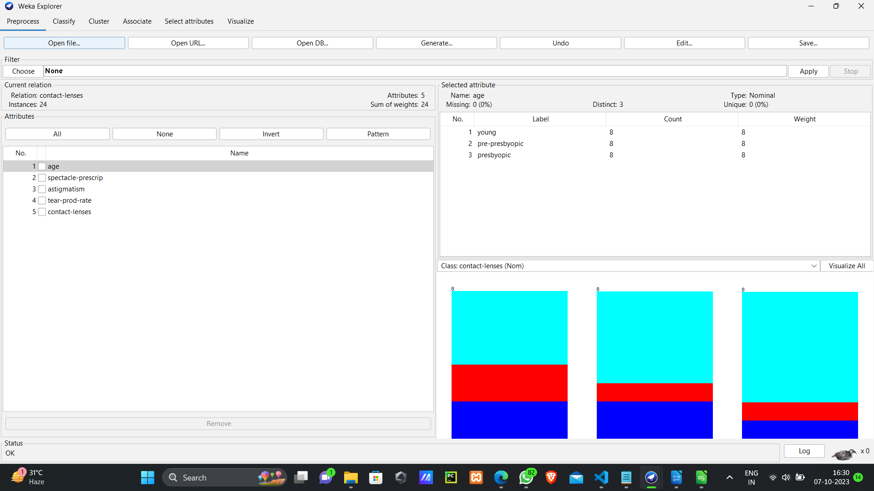

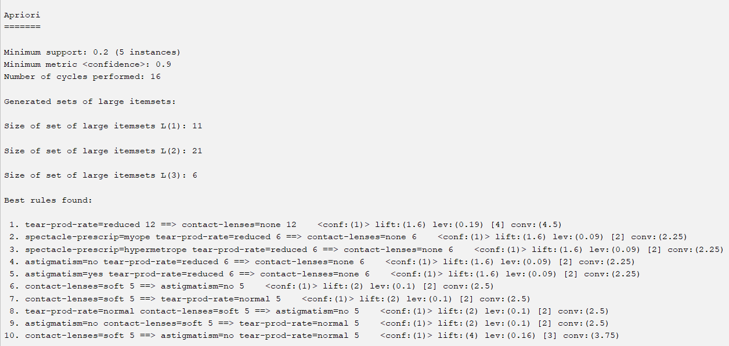

**Conclusion:**